GOVERNMENT COLLEGE OF NURSING, KANPUR

REPORT ON INTERNATIONAL DAY OF MIDWIVES- 2023 CELEBRATION

The International Midwives Day is observed every year on 5th May. The International Confederation of Midwives, a supporting body, has been organising the event since 1992, and it is marked in 50 countries. This year the day is celebrated with the theme Together Again: From Evidence to Reality, which is a is a nod to the upcoming 33rd ICM Triennial Congress, where our global midwife community will come together for the first time in more than five years, in association with international confederation of Midwives, The white ribbon alliance, Jhpiego and UP state Medical Faculty.
Objective of the Programme
- To motivate and reinforce the students to know more about the importance of midwifery practice and NPM course.
- To increase the healthcare and awareness of mothers and their newborns.
- To honour midwives for their great contribution.
- To protect and decrease the rate of maternal health during child birth.
- To motivate policymakers to implement change by recognizing the role of a midwife as well as lobbying for adequate midwifery resources.
General information about the Programme
Date: 04.05.2023
Time: 2 Pm to 4 Pm
Venue: WAC Hall, College of nursing, Kanpur
Event Co-ordinators:
Conveyors:
- Lt. Col. Dr. Karesh Prasad, Principal, College of nursing, Kanpur
- Prof. Naveena JH, Vice Principal, College of nursing, Kanpur
Organizing team:
- Dr.Sunita Chaudhary, Assistant Professor, College of nursing, Kanpur
- Mrs. Lithiya Jose, Associate Professor, College of nursing, Kanpur
- Mrs.Sapnapal, Nursing Tutor, College of nursing, Kanpur
- Mrs. Meenakshi, Nursing Tutor, College of nursing, Kanpur
Participants:
- Faculties of Nursing, College of nursing, Kanpur
- 4th year B.Sc nursing students, College of nursing, Kanpur
- 1st year Post Basic B.Sc Nursing students, College of nursing, Kanpur
- 2nd year Post Basic B.Sc Nursing students, College of nursing, Kanpur

Schedule Of the Programme

S.NO | PROGRAMME | TIMING
1. | Welcome | 2.00 pm-2.10 pm
2. | Lamp lighting | 2.10 pm-2.15 pm
3. | Address by Vice Principal | 2.15 pm -2.25 pm
4. | Address by Principal | 2.25 pm- 2.40 pm
5. | Unveiling theme | 2.40 pm-2.50 pm
6. | Video Presentation | 2.50 pm-3.00pm
7. | Song on Midwives | 3.00 pm-3.10 pm
8. | Presentation on Simulation in midwives | 3.10 pm- 3.30 Pm
9. | Speech on Midwifery Day | 3.30 pm-3.40 pm
10. | Speech on Women’s Health | 3.40 pm-3.50 pm
11. | Vote of thanks | 3.50 pm-4.00pm

Description of the programme
The international midwife’s day 2023 observed on 4th May 2023 at WAC Hall, College of nursing, Kanpur. The programme started at 2 Pm with Saraswati Vandana followed by lamp lighting and welcoming of the dignitaries. Further Prof.Naveena JH, Vice principal sir addressed the gathering and congratulate on IDM. Sir emphasises the role of midwives and the importance of midwifery practices which is followed by Lt.Col . Dr. Karesh Prasad, Principal ma’am address, which really motivated the students to become a midwife in all means and mam also explained the history of midwifery practice in Indian Scenario and importance of the quality care of midwives to reduce MMR & IMR.
Mrs. Lithiya Jose, Associate Professor unveiled the theme of IDM 2023 – Together again: from Evidence to Reality with an introductory speech and video presentation. Mrs. Priyanka Chaudhary, Asst. Professor has presented a most cardinal topic in midwifery – Simulation in midwives which was a knowledgeable session for the students and even for the faculties.
The students Ms. Ragini, B.Sc 2nd year and Ms. Ayushi, B.Sc 1st year has presented a a song on midwives which was self- composed and tuned was a great reinforcement for the gathering. Mr. Ramakanth from 4th year B.Sc nursing and Mr. Abinnaman from 1st year Post Basic B.Sc Nursing has also given the speech on international midwives day and women’s health.
On completion the Vote of Thanks has given By Mrs. Meenakshi Singh and the Programme was hosted by Mrs. Sapna Pal throughout.
On 1st May 2023 we have also organized the competitions like Essay Writing and Poster Making in the college on the theme IDM 2023. We got 22 entries in Essay writing competition and 10 entries in poster making competition. The certificates for the winners and also for the participants will distribute on 12th May - Nurses Day Celebration 2023.
On 5th May 2023, in association with White ribbon alliance, Jhpiego and Upstate medical faculty celebrated International Day of Midwife at Lucknow. Prof. Naveena JH, Vice Principal, College of Nursing, Kanpur attended the programme on behalf of College of Nursing, Kanpur. The faculties and the students were attended the celebration virtually.

The history of Midwifery goes back to prehistory, though there are records all over the world of midwife traditions. In ancient days their practices were based heavily in experience and superstition, today’s midwives are just as capable and competent at seeing a woman. International Midwives Day is observed every year to raise awareness about midwives’ positions and to meet the growing demand for more midwives around the world. It contributes to the global strengthening of midwifery by providing professionally trained midwives to provide high-quality, evidence-based health services to mothers and babies.

GLIMPSE OF THE EVENT

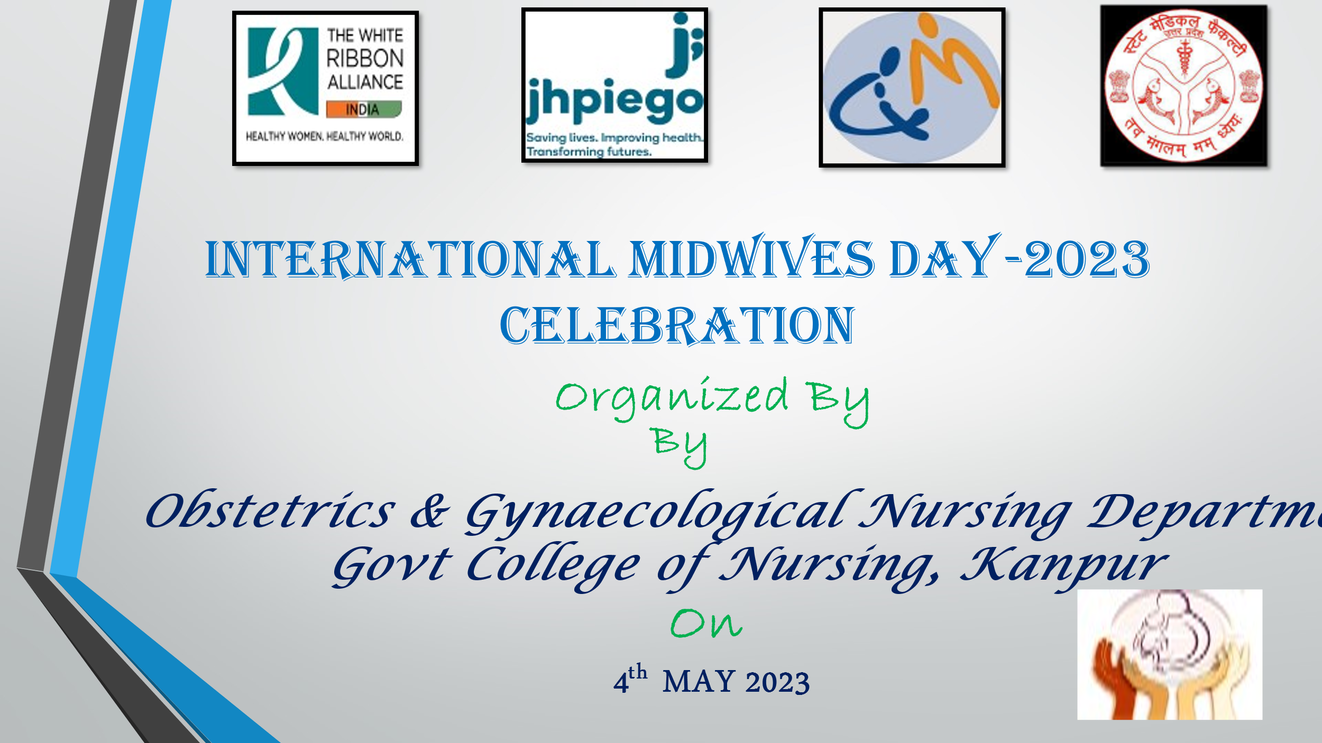

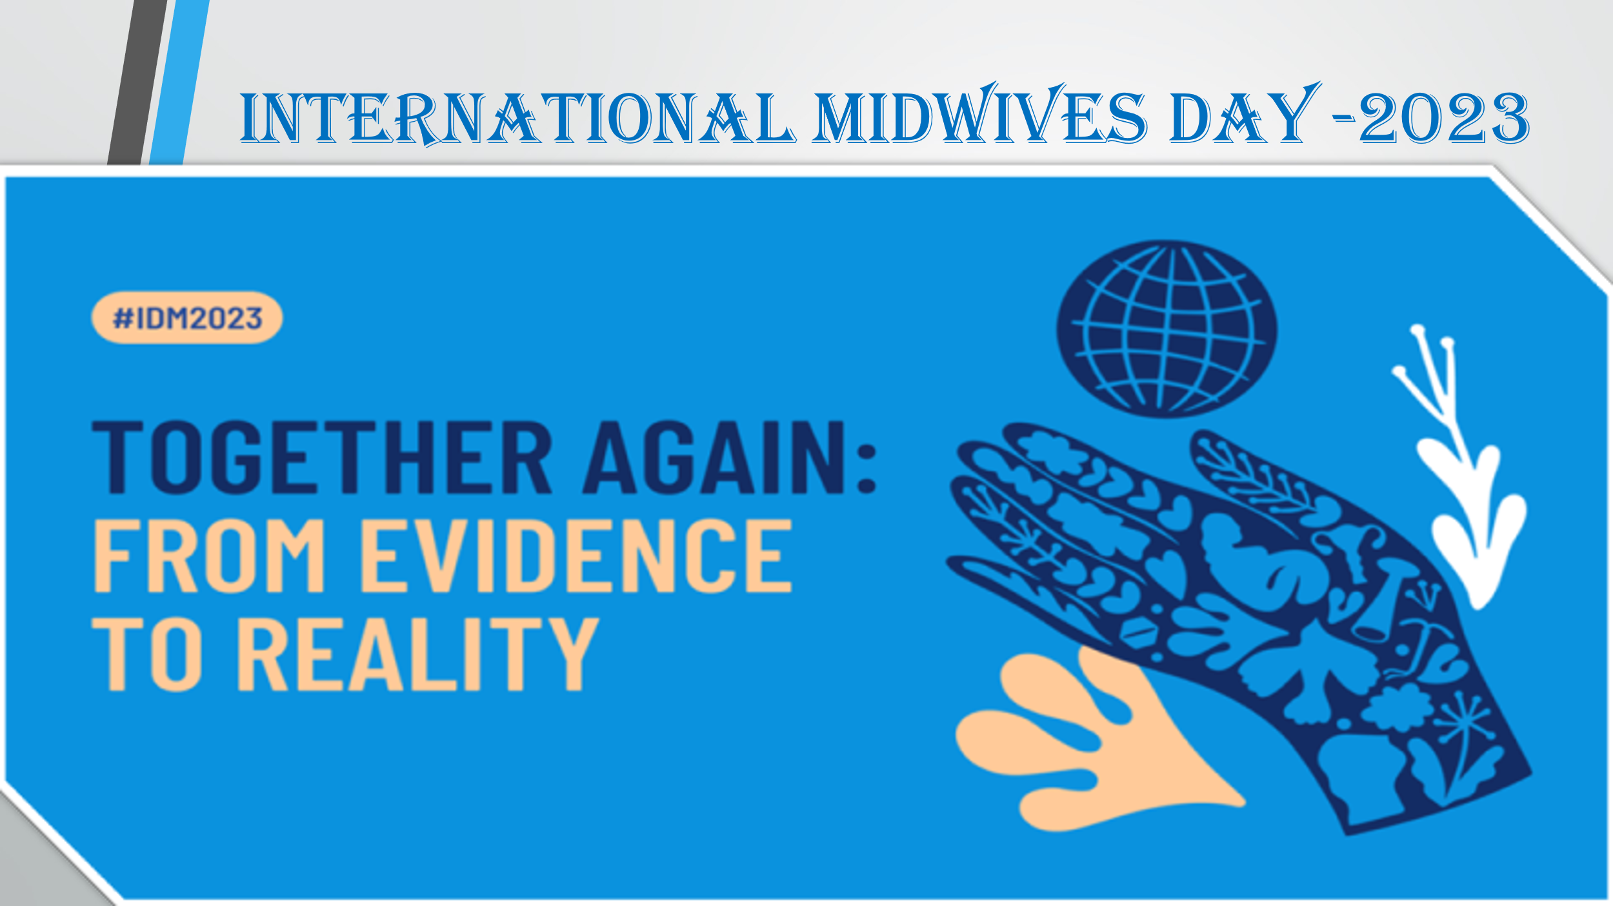

LAMP LIGHTING & INAUGURAL CEREMONY

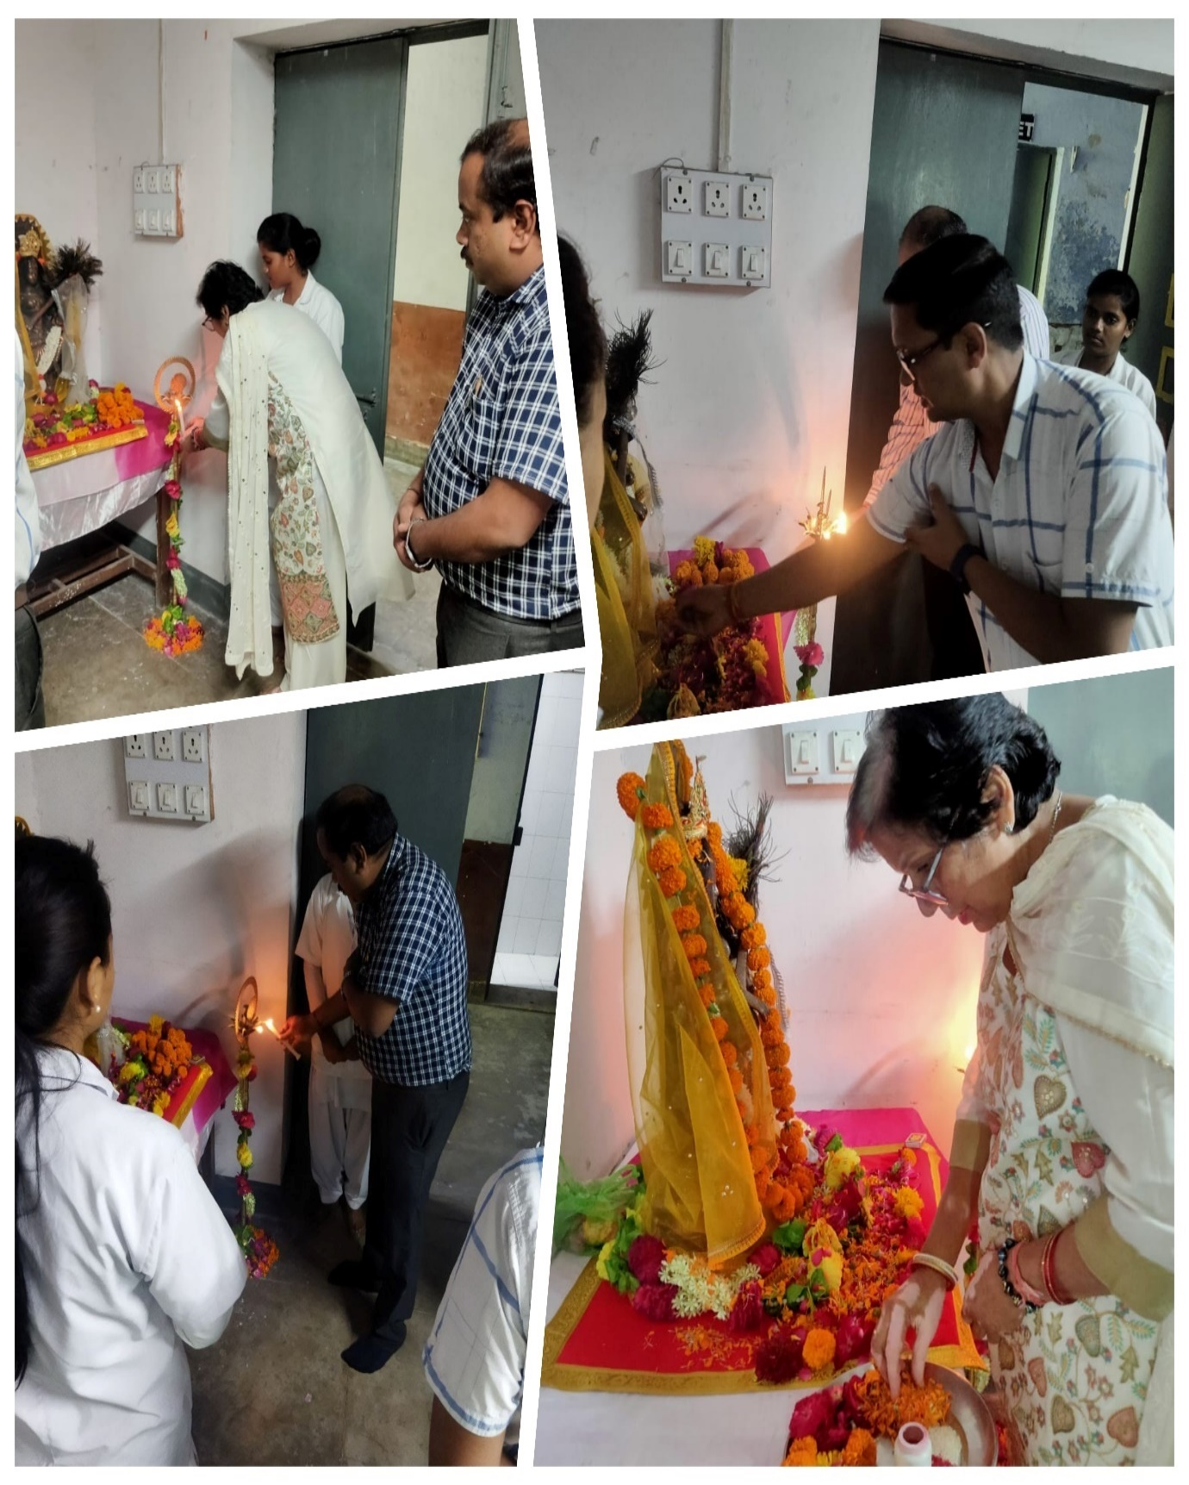

GLMPSE OF THE PROGRAMME

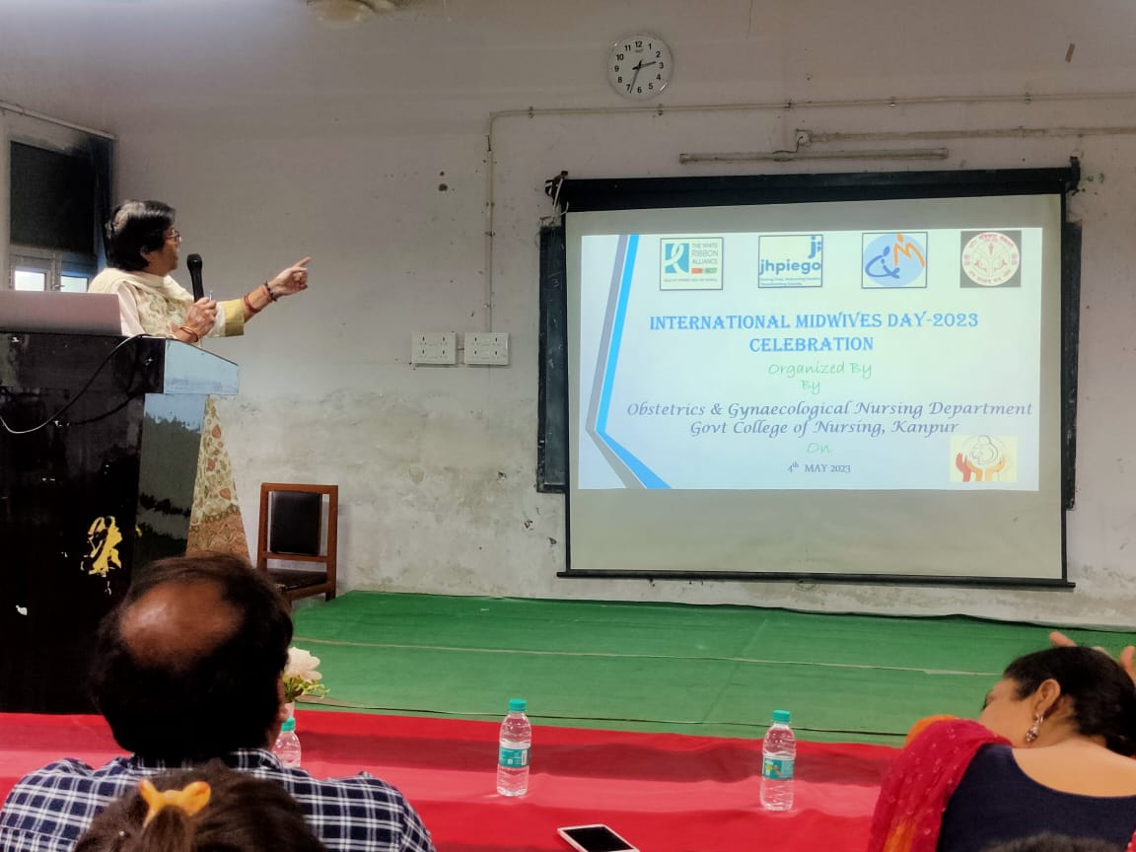

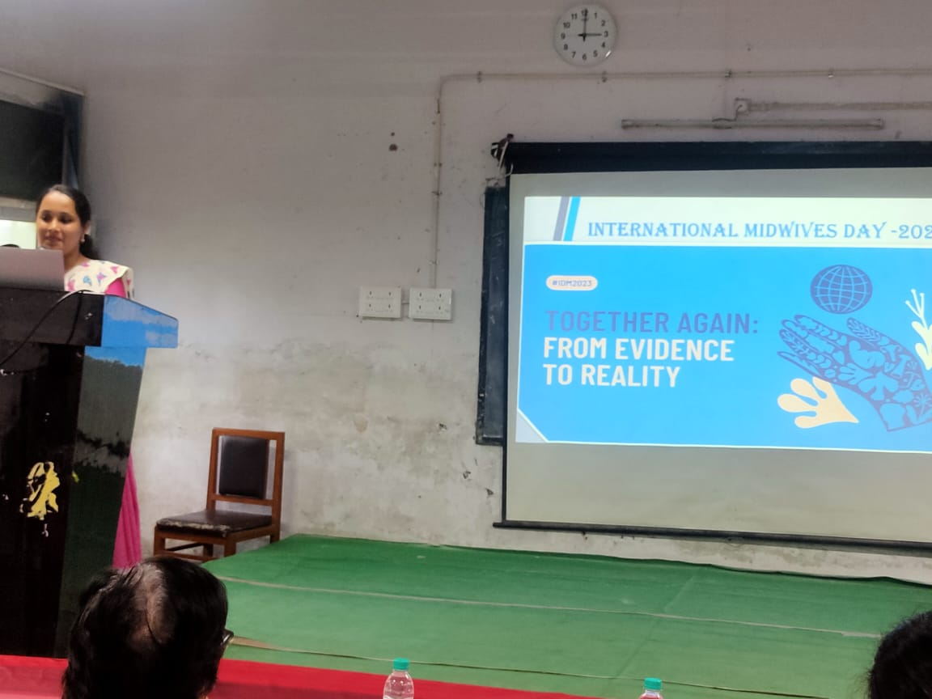
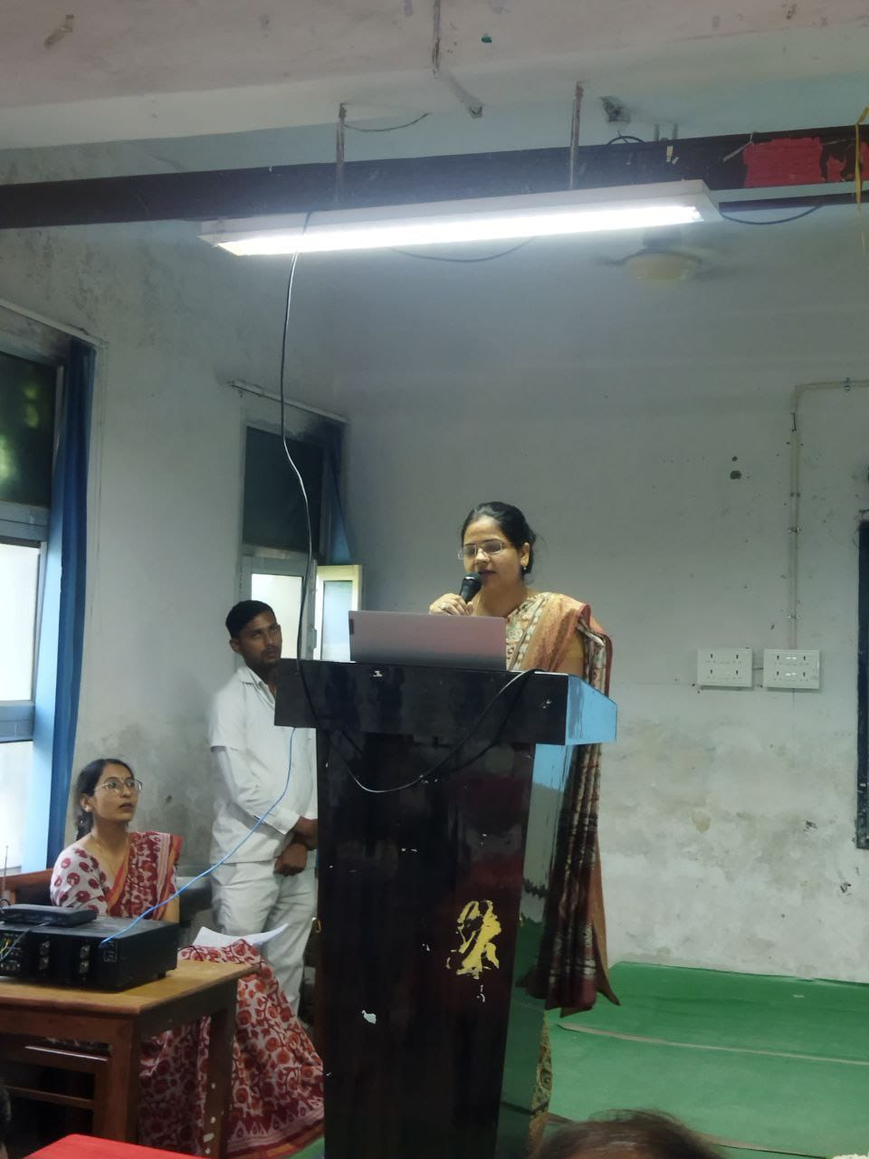

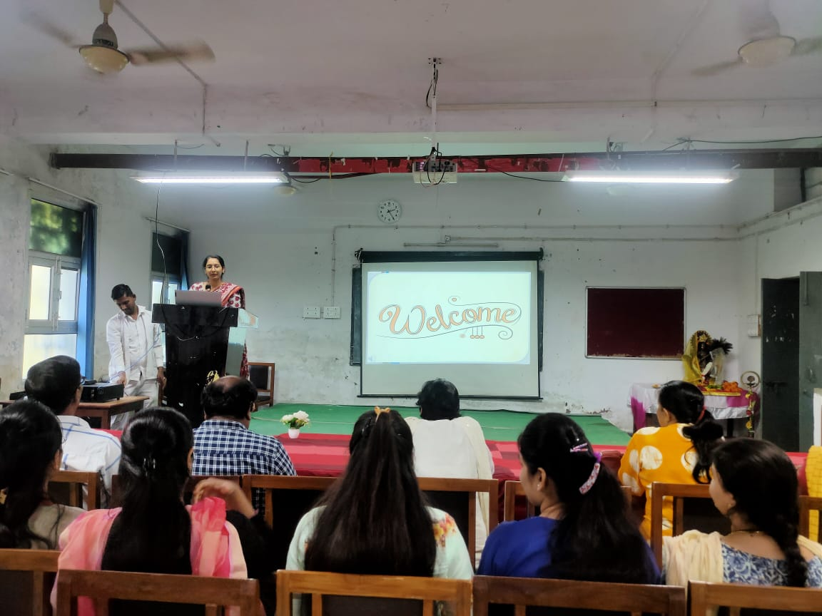

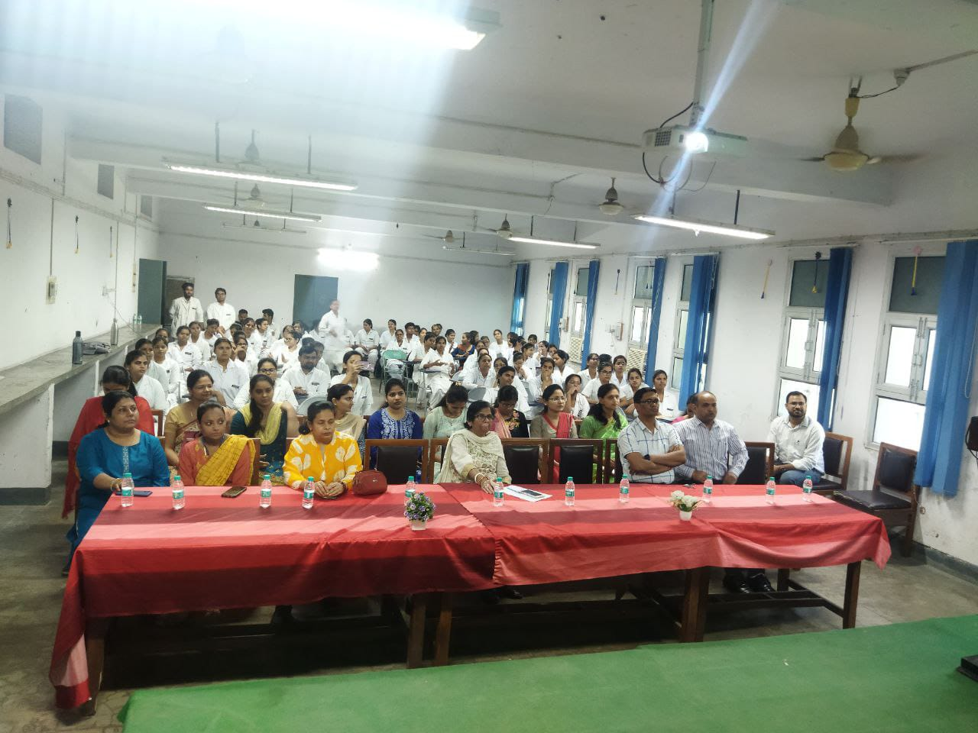
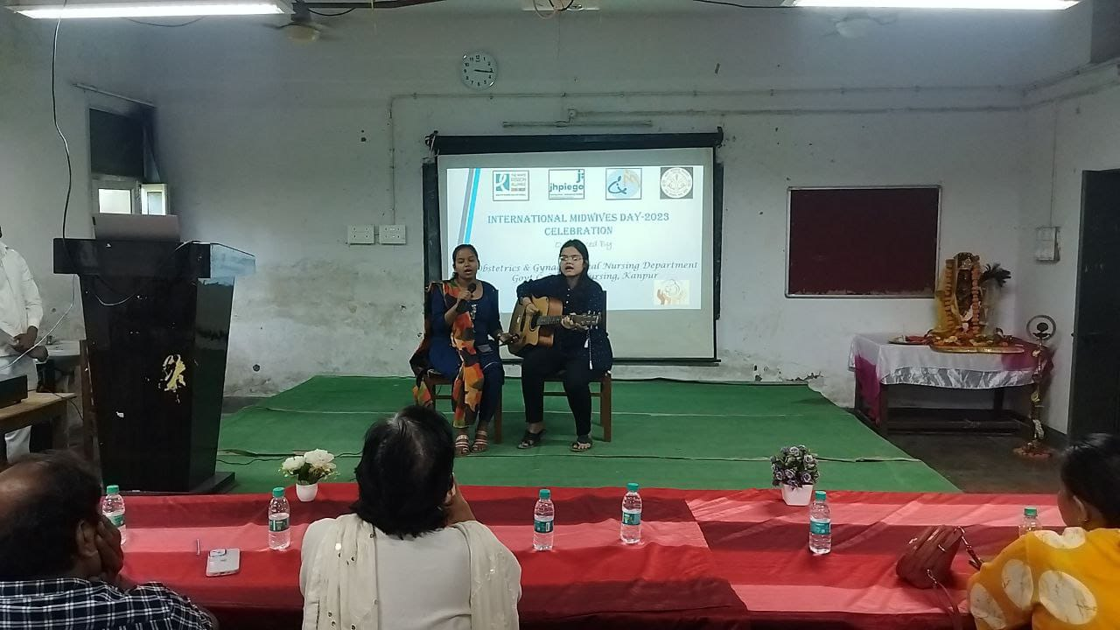

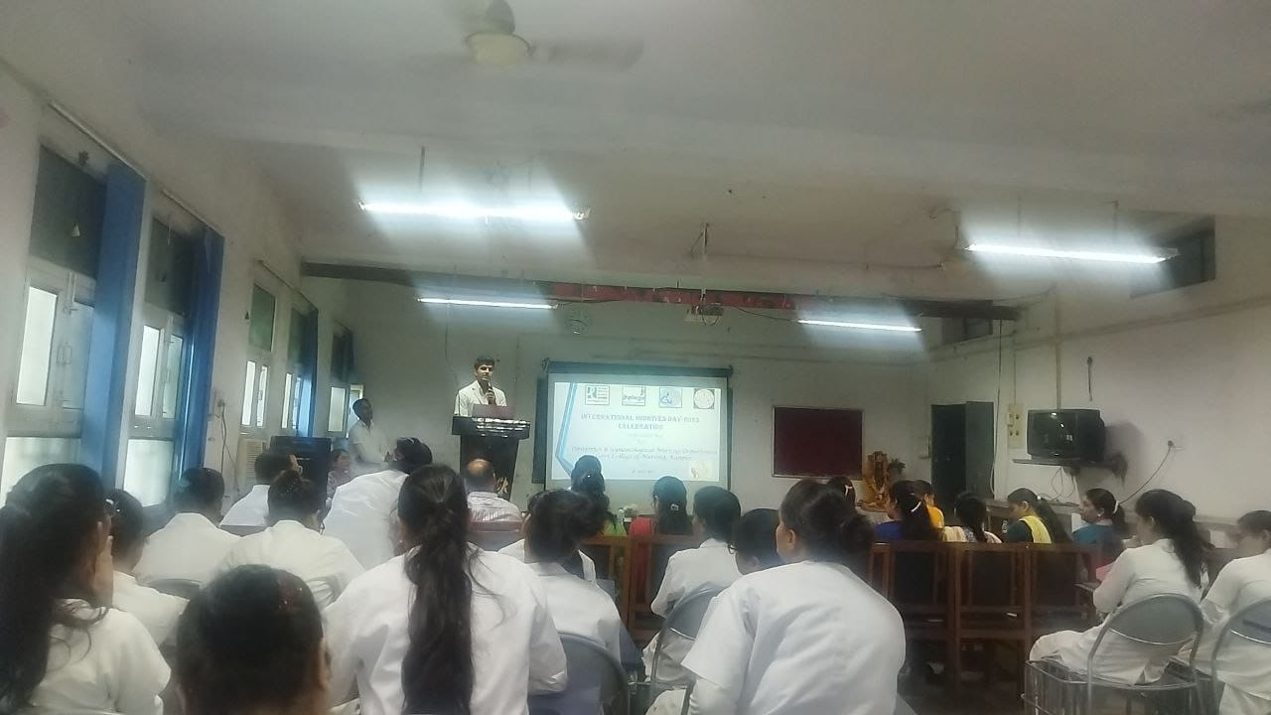

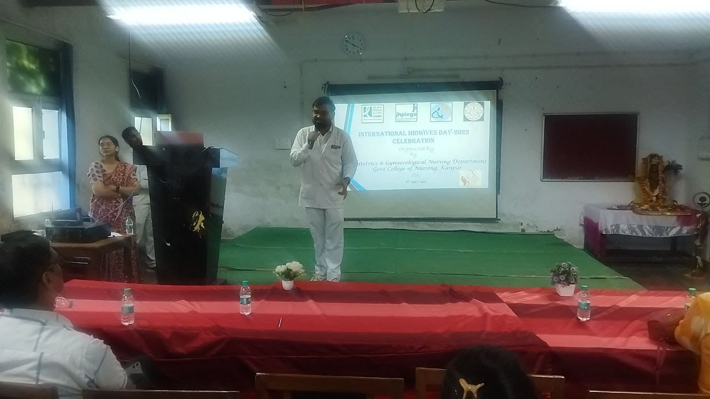

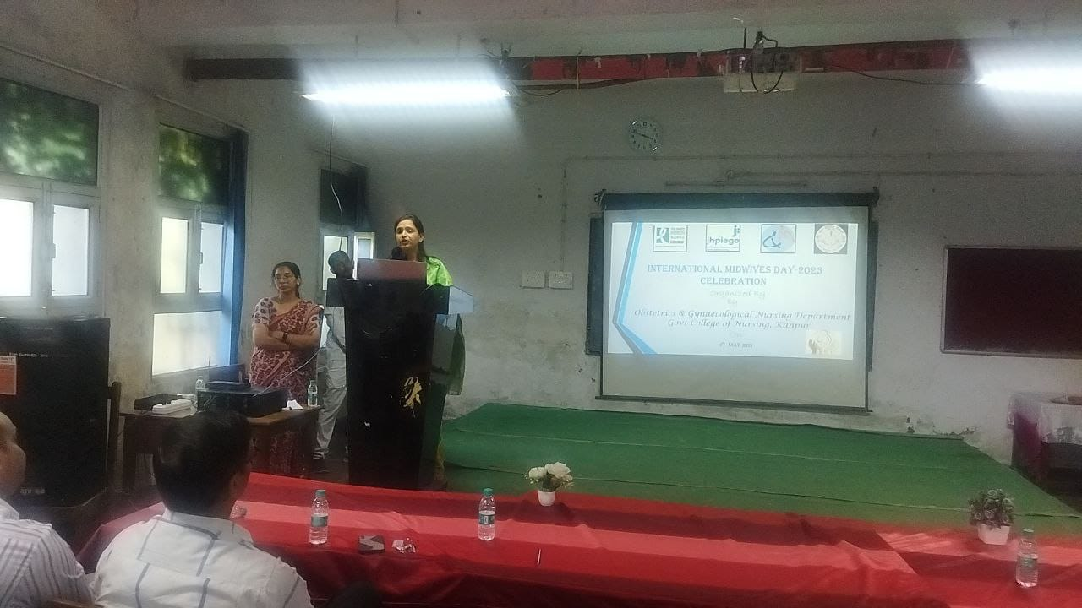

CELEBRATION AT LUCKNOW

VIRTUAL CELEBRATION

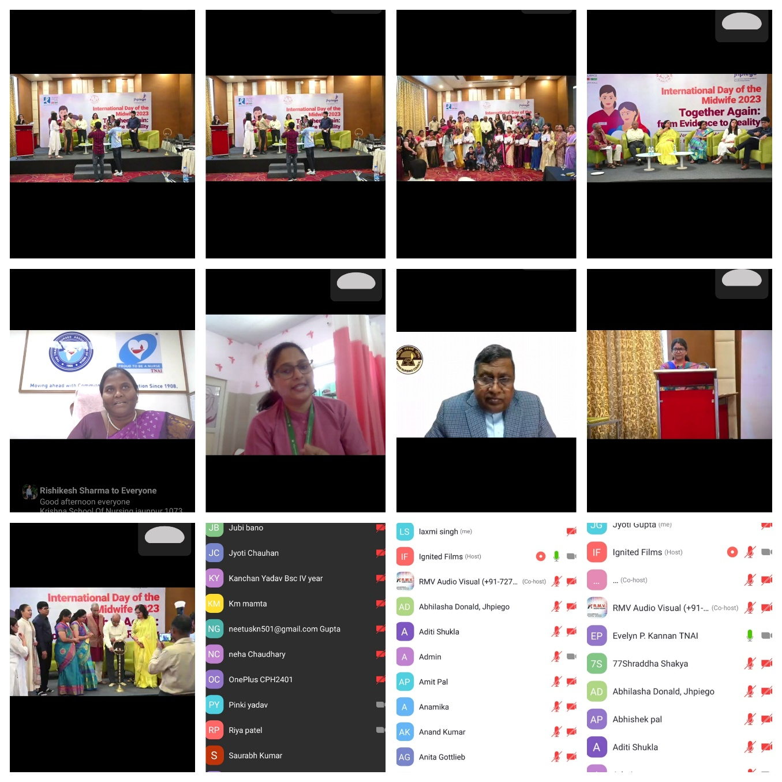

POSTER COMPETITION

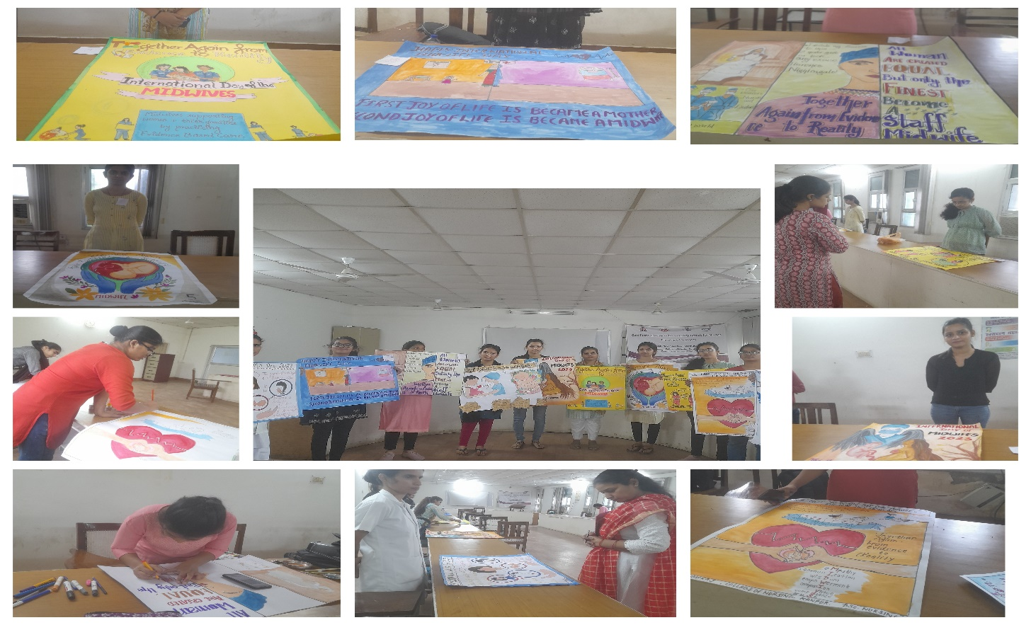

ESSAY WRITING COMPETITION

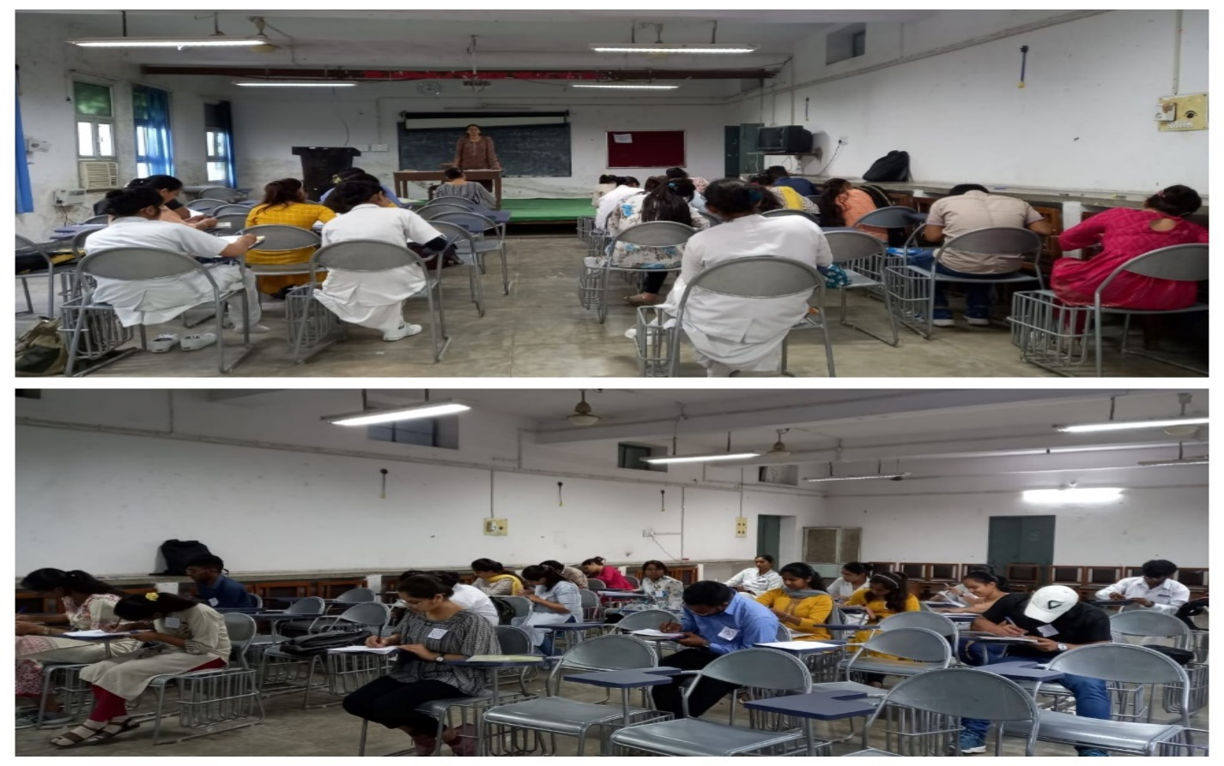
NAME OF THE PARTICIPANTS
ESSAY WRITHNG COMPETITION

S.NO | NAME OF THE PARTICIPANTS
 | AYUSHI MADDHESHIYA
 | AANCHAL
 | SUBRA
 | ABHINNAMAN
 | KIRTI
 | NEERAJ YADAVA
 | ABHISHEK SINGH
 | PREETI PATEL
 | PANKAJ SINGH
 | SWATI KASHYAP
 | SWAGATI TRIPATHI
 | RIZWAN ANSARI
 | PRIYA SINGH
 | RUCHI DWIVEDI
 | NEETU DEVI
 | SWATI SINGH
 | NEETU KUMARI
 | GARIMA SINGH
 | EKTA RAJ
 | ADITI KUSHWAHA
 | SHEETAL BAJPAI
 | ASTHA SINGH

POSTER MAKING COMPETITON

S.NO | NAME OF THE PARTICIPANTS
1. | TOOBA
2. | VAISHNAVI
3. | TANYA AGGARWAL
4. | PRAGATI
5. | HIMANSHI
6. | PREETI MANI
7. | SNEHA
8. | DEEKSHA
9. | SHWETA
10. | RATNA

